Risk & Safety Solutions (RSS) Chemical Inventory
User Reference Guide
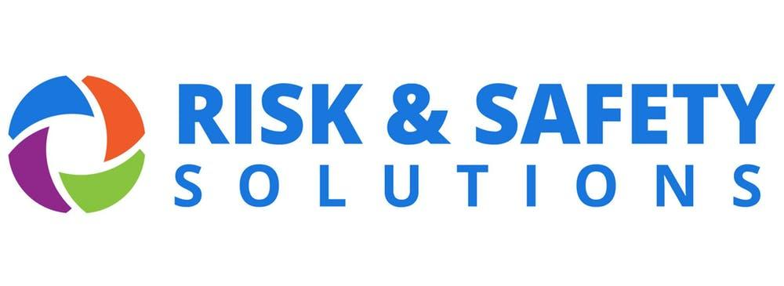
prepared for CSUSM by
Safety, Health & Sustainability
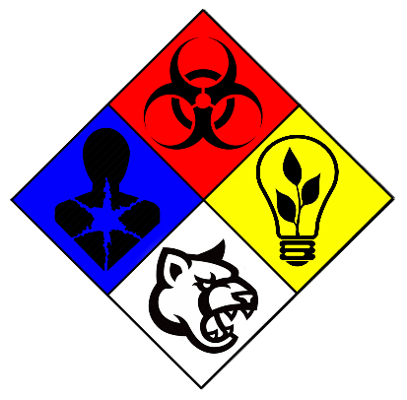
Table of Contents
- Accessing RSS Chemicals
- Viewing/Searching Your Inventory & SDS
- Adding Containers to Your Inventory
- Removing Containers from Your Inventory

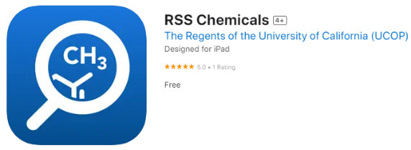
I. Accessing RSS Chemicals
- Go to riskandsafety.com and Sign In,
or use the mobile app “RSS Chemicals”.
- Log in using your campus credentials.
- If using a browser, open the Apps dropdown menu and select Chemicals.
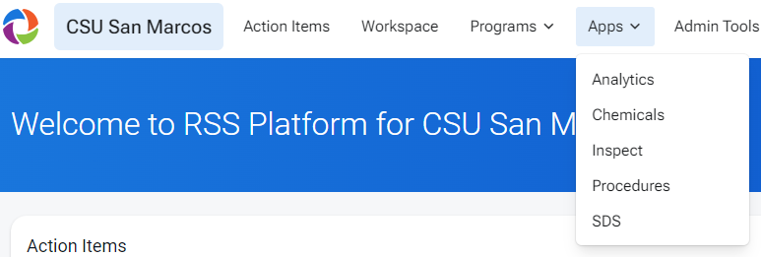
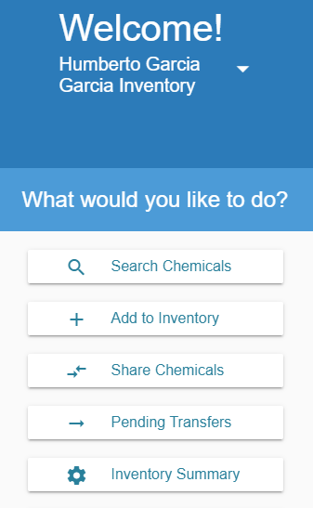
II. Viewing/Searching Your Inventory & SDS
If using a browser:
- Select Search Chemicals to view your inventory. Use the search function to find a specific chemical currently in your inventory.
- Select a chemical’s name to view its information, including how many containers you have of this chemical and the last recorded storage location of each container. You can also search for specific containers.
- To view the chemical’s Safety Data Sheet (SDS), scroll down to the Attachments section and select a PDF from one of the available manufacturers. The SDS will open in a new tab or window.
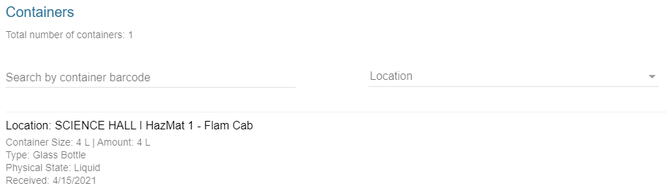
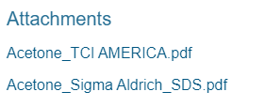
If using the mobile app:
- The app should open in the Inventory tab by default.
- Search and select a chemical’s name to view its information, including container-specific data such as volume and last recorded storage location. You can also Scan the QR code on a container’s RFID tag with your device’s camera to bring up its information.
- To view the chemical’s Safety Data Sheet (SDS), it is recommended to do so in a browser. The links in the Related SDS section may fail to load within the app.
III. Adding Containers to Your Inventory
You can speed up this process for chemicals you already have by “cloning”. See the next page.
- For a new chemical that you do not already have other containers of, select Add to Inventory if using a browser or Chemical Database if using the app.
- Search for the chemical and select its name to view its information.
- Once the correct chemical has been selected, take this moment to affix a new RFID tag to the manufacturer’s container.
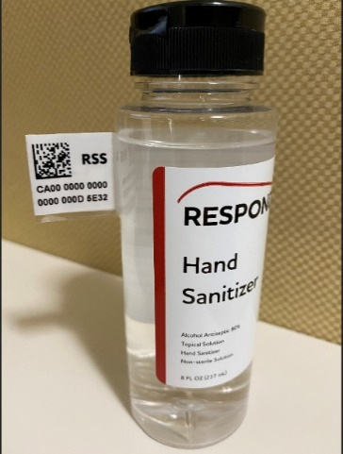
  - Fold along the perforated edges to form a “T” shape so that the tag can be affixed like a flag.
  - Placement should be high along the side, near or on the neck of the bottle. Do not place tags on the cap.
  - Avoid obscuring any information on the label.
  - For containers stored below ambient temperature, wipe the surface down with a clean rag before affixing a tag.
  - Particularly difficult containers may be placed inside plastic bags with tags affixed to the bags instead.
  - For tiny containers, record the names and CAS # on a sheet of paper and affix the tag next to each name.
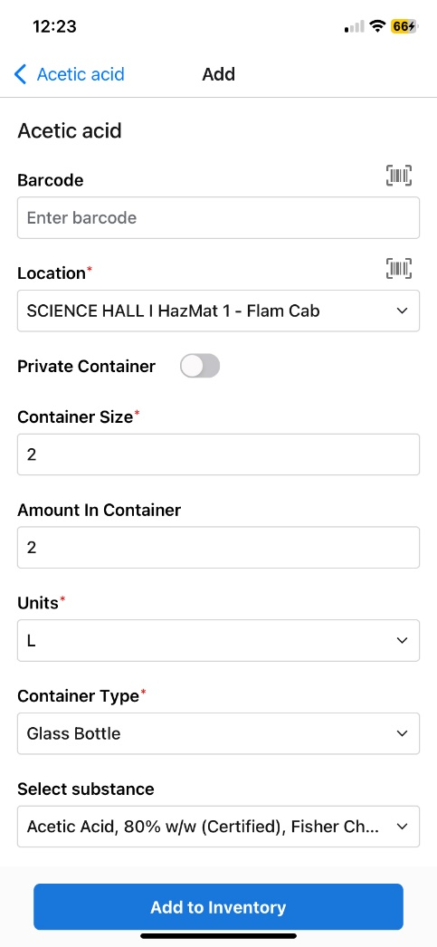
  - To request RFID tags, contact SH&S (ext. 4502).
- Click the add icon () in the Containers section or tap Add Container and fill out the required fields.
  - Barcode: If using the app, tap the barcode icon to use your device’s camera to scan the QR code on the RFID tag to automatically populate the field.
  - Amount in Container can be defaulted to the value in Container Size if unknown.
  - Substance: If the product name printed on the manufacturer’s container varies from the chemical name as it appears in RSS Chemicals, select the option in this dropdown menu that most closely matches the printed name.
  - Private Container should be left unselected or as “No”.
  - Concentration should match what is printed on the bottle, if applicable.
  - Expiration/Opened Date should be left blank if unknown.
- Select Save or Add to Inventory once finished.
Cloning containers
- Search for the chemical as described in section II to view your current inventory (switch to the Containers tab after searching if using the app). For max efficiency, choose one that has the same container size, type, and/or sublocation as the new container(s) you want to add.
- Click the corresponding more icon () under the Containers section if using a browser or tap your selection if using the app, then select Clone. Be sure to assign it a new RFID and change any other details as needed.
IV. Removing Containers from Your Inventory
If using the mobile app:
Tap Scan at the bottom of the screen and change “View Container” to “Remove Containers”. Use the camera to scan the QR code on the RFID tag. You can quickly queue multiple bottles for deletion using this method. Once finished, tap Remove Containers.
If using a browser:
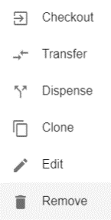
Under the Containers section, click the corresponding more icon () and select Remove. The container will be “Marked for Deletion” and appear in a column titled “Containers to Delete”. If you wish to remove more chemicals, simply select the remove icon () in the container’s row to add it to the column. Once finished, select Delete and Confirm to remove all the containers that were in the column.
If the chemical or its container needs to be managed as hazardous waste, please deface the letters “RSS” on the RFID tag with marker to indicate to SH&S that it has been removed prior to pick-up.
