DATA WAREHOUSE BASE BUDGET DOWNLOAD AND PIVOT ANALYSIS BY SCENARIO

- Data Warehouse
- Financial Summary as of Period tab
- Run Dept Level 4 Fdescr only so it brings in all funds, departments, accounts, etc. and you have one budget number to drill into (or if you manage just one DEPT ID just use that) – run open, do not exclude benefits or anything else.

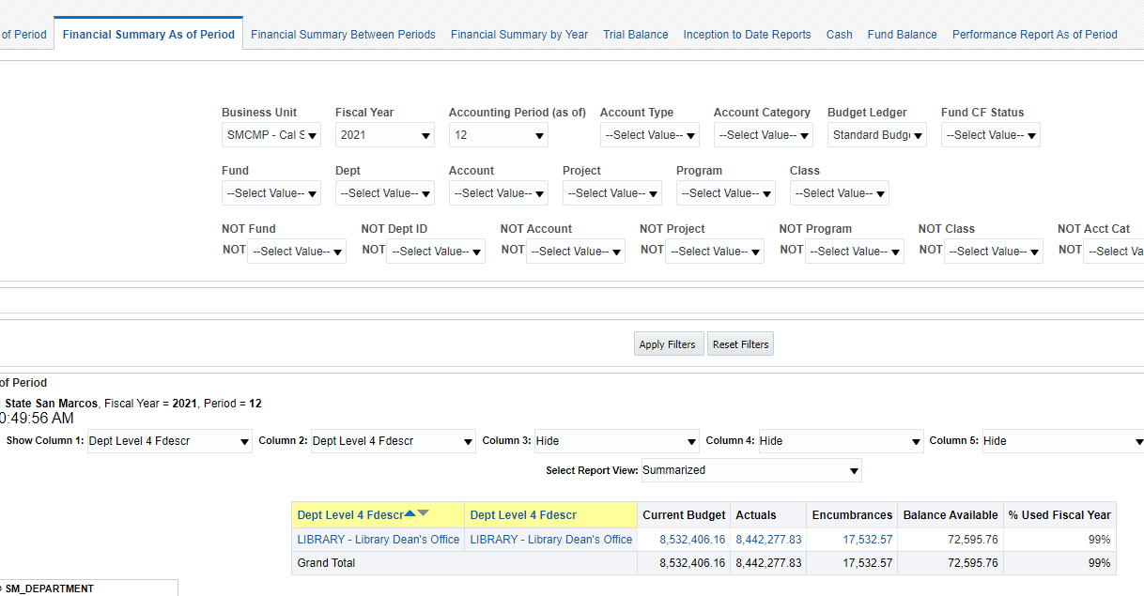

- Drill into the current budget (click on the blue numbers)
- Go to the bottom of the drill down and click on ‘Export’ then ‘CSV Format’ – it will download the excel budget in csv format so you can make a pivot to analyze by scenario (BBB, BBS, BBT for all base).
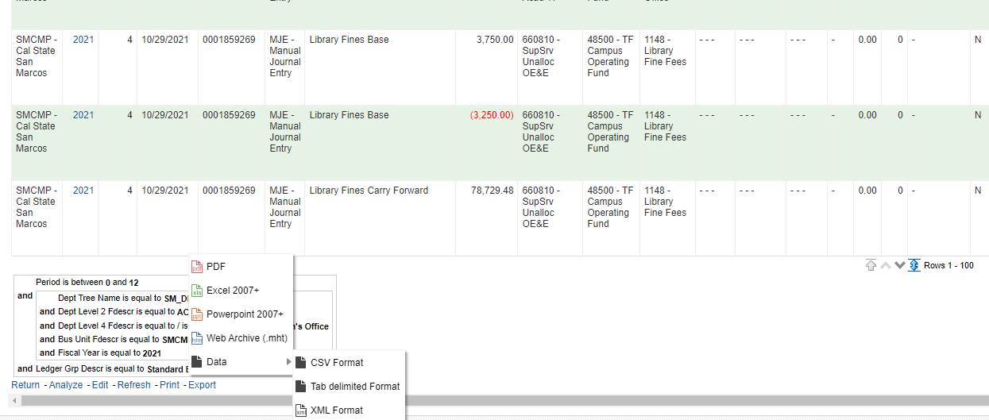

- Make sure to save as an excel workbook, not csv or you will lose your pivot when you save or send.
  - File then Save As ‘Excel Workbook’ rather than CSV. 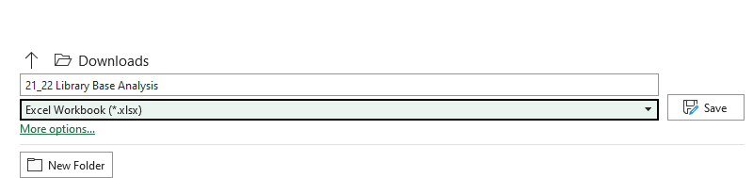
- To analyze by scenario in a pivot:

  - Mouse anywhere in the data – ‘Insert’ then ‘Pivot Table’ and ‘From Table/Range’
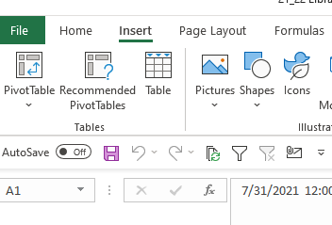
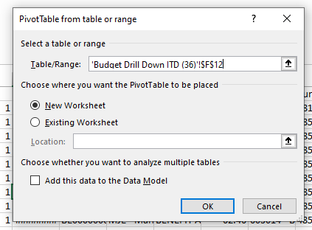

- Set up your pivot based on the analysis you want. Sample of a base scenario pivot by Line Description (names have been changed):
