Student Engagement at Cal State San Marcos:
Findings of the Spring 2014 National Survey of Student Engagement

The National Survey of Student Engagement (NSSE) is a national survey that “collects information at hundreds of four-year colleges and universities about first-year and senior students’ participation in programs and activities that institutions provide for their learning and personal development. The results provide an estimate of how undergraduates spend their time and what they gain from attending college.” Cal State San Marcos has participated in the NSSE since 2000, most recently on a bi-annual basis. In 2013, NSSE underwent a significant revision changing, deleting or adding questions to the survey. They also provided optional modules covering important topics. This year, our campus added the Advising module and also joined a coalition of other CSU campuses that allowed for additional CSU-specific items.
In late fall 2013, CSUSM provided the email addresses of freshmen and graduating seniors to the Center for Survey Research at Indiana University which, in turn administered the survey in spring 2014. With the help of ASI, we were able to do additional publicity for the survey and achieved a 25% response rate for freshmen (N=492) and a 37% response rate for seniors (N=491), a response rate that is higher than other participating universities.
The first part of this report summarizes the differences in responses between CSUSM and of two similar groups: other CSU campuses and other Master’s-level institutions participating in the 2014 NSSE. The second part highlights selected differences in responses by underrepresented minority (URM) status, gender, and entry status (seniors only). Freshmen and senior respondents are presented separately within these groups because it cannot be assumed that senior responses represent what freshmen respondents are likely to articulate at the close of their college careers since so many of the senior respondents came to Cal State San Marcos as transfer students.
CSUSM Respondents vs. Respondents from Comparison Campuses
Researchers at Indiana University have developed indicators based on NSSE items that summarize students’ level of engagement. These ten indicators are organized within four themes: Academic Challenge, Learning with Peers, Experience with Faculty, and Campus Environment. As shown in the graphic below, CSUSM freshmen respondents’ ratings are much higher than those of similar campuses in most areas. Our seniors are similar to those at other CSU campuses but rate many other aspects higher than respondents at other Master’s level campuses with two exceptions: student-faculty interaction and the supportive nature of the campus environment.

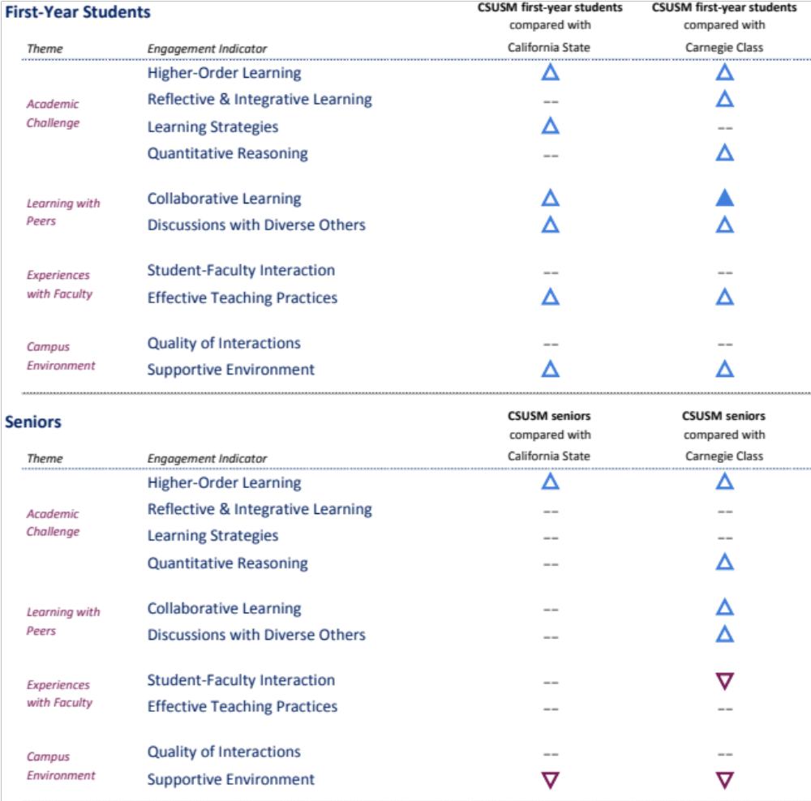
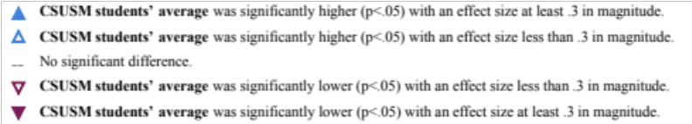

Academic challenge
More than three-fourths of CSUSM respondents reported that their coursework emphasized the following higher-order learning skills:
- Applying facts, theories, or methods to practical problems or new situations
- Analyzing an idea, experience, or line of reasoning in depth by examining its parts
- Evaluating a point of view, decision, or information source
- Forming a new idea or understanding from various pieces of information
Learning with peers
Our students were particularly strong in the area of collaborative learning. Items measuring this indicator included how often respondents asked other students for help, explained material to other students or interacted with students who were different from themselves. More than three-quarter of CSUSM freshmen say they frequently talked with people from other race/ethnicities or from other economic backgrounds. Seniors were equally strong in this area; the difference between our seniors and those at other campuses was just not as great.
Experiences with faculty
Freshman and senior respondents gave generally high ratings to the effectiveness of faculty teaching practices. For example, four of five respondents said faculty “clearly explained course goals and requirements” and “taught courses in an organized way”. Our students’ responses were on par with those of students elsewhere with less than one-third of CSUSM respondents reporting that they “often/very often” had discussions with faculty members outside of class.
Campus environment
CSUSM freshman were more likely than respondents elsewhere to see the campus as supportive in all areas. More than three-quarters said the campus provided support to help them succeed academically and socially. CSUSM seniors were less likely than seniors elsewhere to see the campus as supporting them academically, providing social opportunities, or helping them manage non-academic responsibilities. They were also less apt to participate in co-curricular activities or to attend campus events.
Additional Activities that Foster or Hinder College Success
Compared with respondents at other CSU and Mater’s level campuses, CSUSM respondents spend less time preparing for class, are slightly less likely to work on campus and less likely to participate in co-curricular activities—all activities thought to foster engagement with their studies. Furthermore, CSUSM freshmen respondents were more likely than other respondents to:
- work for pay off campus (40% vs. 28% of CSU respondents)
- provide care for dependents (37% vs. 29% for CSU and 20% for other MA campuses)
- to commute five or more hours/week (31% vs. 18% of freshmen at Master’s level campuses; 40% vs. 24% of seniors at other Master’s level campuses).
Approximately 40% of CSUSM respondents said that most of their class preparation time is spent reading and more than three-quarters have come to class without completing their reading assignments.
Written and Oral Communication
CSUSM students’ responses continue to reflect our emphasis on written and oral communication. Our students were more likely to have written papers up to 10 pages long and much more likely to have written papers over 10 pages (49% of CSUSM freshmen vs. 22% of CSU freshmen; 66% of CSUSM seniors vs. 60% of CSU seniors). One in five respondents said their education had substantially increased their ability to write clearly and effectively and 83% of freshmen and 71% of seniors said their education had improved their ability to speak clearly and effectively. More than two-thirds of both freshman and senior respondents said they had given a course presentation and 61% of freshmen and 76% of seniors reported asking questions in class.
High Impact Practices
The NSSE asks students about their participation in the six high impact practices that are important “due to their positive associations with student learning and retention” (2014 NSSE report). Responses by seniors included participation in any of the practices from prior years, not just the current year. As shown in the chart below, two-thirds of our freshmen and 88% of our seniors report participating in a least one high-impact activity with especially strong involvement in service-learning.
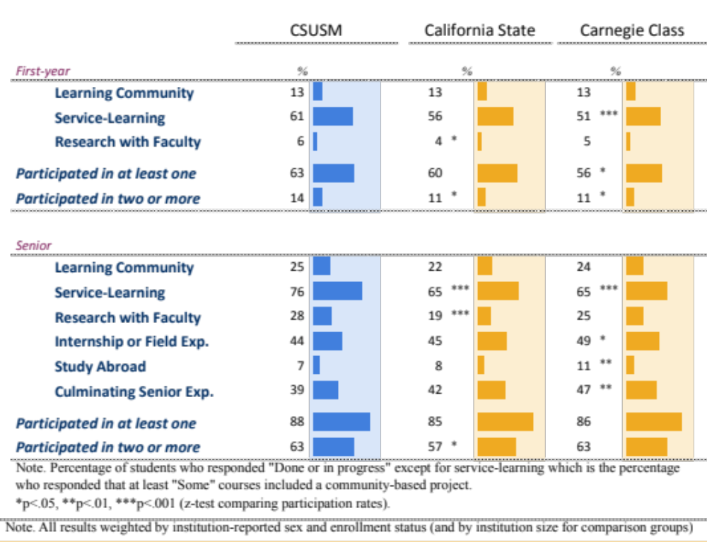

Overall rating of time at CSUSM
The vast majority of CSUSM respondents continue to give high ratings to their educational experience at CSUSM. The percentage rating their experience as “good or excellent” has increased from 79% in 2005 to 87% in 2014. Similarly, at least 78% of respondents say they would choose CSUSM again if they had to start over compared with 65% in the Spring 2005
CSU-Specific Items
CSU campuses participating in the 2014 NSSE were part of a consortium that developed CSU-specific questions that were added to the NSSE. The items centered on areas of particular concern to most CSU campuses: course availability, progress to degree and campus safety.
Course availability
Although half of San Marcos respondents took courses for “personal enrichment” that were not required for their major or GE, they were less likely to do so than respondents on other CSU campuses. CSUSM freshmen respondents were more likely to say they took classes that were not required because they thought they were required for their major. Although three-quarters of our freshmen respondents said they were able to get their required GE courses most of the time/almost always, fewer said they were able to get the classes they needed for their majors. One quarter of freshmen and 32% of seniors took extra classes because they could not get the classes they wanted.
Progress to degree
Just over half of CSUSM freshman respondents say they were working either on or off campus compared to nearly 80% of seniors. The primary reasons cited for working are to earn money for college and for basic expenses rather than to gain experience or to earn “extra” spending money. Freshmen respondents are more likely than seniors to be concerned about financial problems delaying their education. Those who have experienced such difficulties (approximately 25%) say they enrolled in community college to reduce costs.
The vast majority of CSU respondents say the following were important to their college success:
- ability to interact with faculty and students in class
- access to supplemental instruction
- free tutoring/writing assistance.
One-third of CSUSM freshmen and one-half of seniors considered themselves more prepared than their peers in their GE courses. Finally, more than three-quarters of our respondents said they feel very safe on campus compared to half at other CSU campuses.
Advising
The 2014 NSSE included an optional module with questions specific to advising. CSUSM elected to administer this module to our students. For these items, the comparison group was comprised of only those campuses that administer this module. One-quarter of our respondents said they had never had a discussion with an academic advisor, a rate that is lower than respondents at other campuses, and one-third of freshmen get their advice about college from family or friends. Among those respondents who had seen an advisor, a majority found them helpful and attentive.
Underrepresented Minority (URM) vs. Non-underrepresented Minority Students
Freshman URM respondents differ from Non-URM respondents is several important ways. They are less likely to live on campus, report taking courses per term, less likely to be making A’s, and more likely to be first-generation students. In spite of these differences, URM students are no less likely to engage in activities that foster engagement. They were more likely to be happy with their experience at CSUSM and to say they would choose the university again if they were starting over.
Academically, URM freshmen respondents were more likely to say they felt challenged by the coursework and that the campus substantially emphasizes studying and reading. Senior URM respondents were less likely than non-URM respondents to come to class unprepared and more likely to say college has improved their ability to write clearly and effectively. URM respondents were more likely to give higher ratings to their interactions with their instructors and to see benefits from advising.
Men vs. Women
Male and female responses are similar in most ways including their satisfaction with their time at CSUSM. The differences are centered around academics, with women more likely to find the coursework challenging, to spend most of their study time reading and less likely to use quantitative methods in their analysis or to ask questions in class. Freshmen men are more likely to report discussing class topics with faculty outside of class and to have a more positive evaluation of faculty. Female freshmen respondents are more likely to say college has contributed to these skills:
- Writing clearly and effectively (84% vs. 75%)
- Speak clearly and effectively (86% vs. 74%)
- Working effectively with others (80% vs. 67%)
- Solving complex real world problems (67% vs. 55%)
- Understanding people of other backgrounds (79% vs. 61%)
First-time Freshman vs. Transfer Students
Senior respondents who came to CSUSM as freshmen (native) generally rate their experiences more positively than those who came here as transfer students. Even though transfer respondents are more likely than native students to say they study more than 10 hours/week, and report writing more and longer papers (an average of 100 pages vs. 85 pages for native respondents), native respondents are more likely to say college has increased their ability to write clearly and effectively. Transfer respondents are much less likely to report participating in co-curricular activities, somewhat less likely to work but more likely to be providing care for dependents. They are also less likely to have taken service-learning courses or to have spent time volunteering.
Native respondents are more likely to have completed internships or to have studied abroad. They also reported more interaction with faculty members, higher ratings of classroom teaching and were more likely to see the campus as supportive. They were more likely to report meeting with an advisor and to have received assistance from them. Finally, native students were more likely to say that their college education had contributed to their speaking skills, their ability to work with others and their ability to solve real-world problems.

Appendix A – Campuses in Comparison Groups

'California State' institutions (N=17)
California Maritime Academy (Vallejo, CA)
California Polytechnic State University-San Luis Obispo (San Luis Obispo, CA)
California State Polytechnic University-Pomona (Pomona, CA)
California State University-Bakersfield (Bakersfield, CA)
California State University-Channel Islands (Camarillo, CA)
California State University-Chico (Chico, CA)
California State University-Los Angeles (Los Angeles, CA)
California State University-Stanislaus (Turlock, CA)
California State University, Fullerton (Fullerton, CA)
California State University, Monterey Bay (Seaside, CA)
California State University, Northridge (Northridge, CA)*
California State University, Sacramento (Sacramento, CA)
California State University, San Bernardino (San Bernardino, CA)
Humboldt State University (Arcata, CA)*
San Francisco State University (San Francisco, CA)
San Jose State University (San Jose, CA)
Sonoma State University (Rohnert Park, CA)

'Carnegie Class' institutions (N=47)
Adams State University (Alamosa, CO) | Southwest Minnesota State University (Marshall, MN)*
Albany State University (Albany, GA) | Southwestern Oklahoma State University (Weatherford, OK)
Angelo State University (San Angelo, TX)* | SUNY Empire State College (Saratoga Springs, NY)
Central Washington University (Ellensburg, WA) | SUNY Institute of Technology at Utica-Rome (Utica, NY)
College of Charleston (Charleston, SC)* | The Richard Stockton College of New Jersey (Galloway, NJ)
Delaware State University (Dover, DE) | The University of Tennessee Martin (Martin, TN)
Fayetteville State University (Fayetteville, NC) | The University of Texas at Brownsville (Brownsville, TX)
Fredonia State University of New York (Fredonia, NY) | The University of Texas of the Permian Basin (Odessa, TX)
Grambling State University (Grambling, LA) | Truman State University (Kirksville, MO)
Henderson State University (Arkadelphia, AR) | University of Minnesota Duluth (Duluth, MN)
Humboldt State University (Arcata, CA)* | University of Montevallo (Montevallo, AL)
Longwood University (Farmville, VA) | University of North Carolina at Pembroke (Pembroke, NC)
Mansfield University of Pennsylvania (Mansfield, PA)* | University of South Florida-St. Petersburg Campus (St. Petersburg, FL)*
Metropolitan State University (Saint Paul, MN)* | University of Wisconsin-Eau Claire (Eau Claire, WI)
Midwestern State University (Wichita Falls, TX) | University of Wisconsin-River Falls (River Falls, WI)
Minnesota State University Moorhead (Moorhead, MN)* | University of Wisconsin-Stevens Point (Stevens Point, WI)
Minot State University (Minot, ND)* | Washburn University (Topeka, KS)
Montana State University Billings (Billings, MT)* | Weber State University (Ogden, UT)*
New Mexico Institute of Mining and Technology (Socorro, NM)* | Western Connecticut State University (Danbury, CT)*
Nicholls State University (Thibodaux, LA) | Western Oregon University (Monmouth, OR)
Northern Michigan University (Marquette, MI)* | Westfield State University (Westfield, MA)*
Ramapo College of New Jersey (Mahwah, NJ) | Winona State University (Winona, MN)*
Southern Polytechnic State University (Marietta, GA) | Winston-Salem State University (Winston-Salem, NC)

NSSE homepage: http://nsse.iub.edu/html/about.cfm
See Appendix A for complete list of comparison campuses.
Master’s-level colleges and universities offer a variety of baccalaureate programs, as well as a number of graduate programs leading to the Master’s degree (Carnegie). A complete our comparison campuses can be found in Appendix A.
Entry status: started CSUSM as first-time freshman vs. transfer student.
URM: African-American, Hispanic, Native American, & Pacific Islander.

